PROBLEM X

Step A) Write a list of integers J

Step B) Underneath J, write another list of integers Z which you get by replacing every number from the list J with the average value of all the numbers before the current one, including it.

For example if the first list of integers J is equal to

1, 3, 2, 6, 8

then the second list of integers Z

(1)/1 , (1+3)/2, (1+3+2)/3, (1+3+2+6)/4, (1+3+2+6+8)/,

OR

1,2,2,3,4

**You are given the second list of integers Z.**

**Determine the first list of integers J.**

INPUT

1st line of input contains the integer N (1 <= N <= 100), the length of list Z.

2nd line of input contains the list of N space-separated integers Zi (1 <= Zi < 109)

OUTPUT

The first and only line of output must contains a list of N space-separated integers Ji

NOTE: the input data allows the elements from the list J to be all integers (1 <= Ji < 109)

Samples:

|  |  |  |
| --- | --- | --- |
| Input:  1  2 | Input:  4  3 2 3 5 | Input:  5  1 2 2 3 4 |
| Output:  2 | Output:  3 1 5 11 | Output:  1 3 2 6 8 |

PROBLEM Y

My Nokia 3310 fell into a puddle and is not working at all. The keyboard works in a completely unpredictable manner and when I press one of the keys, it acts like I pressed another key. Luckily, there are **no two keys that are acting the same so I can still write all the letters**.

I think I figured out how each key acts, but now I want to write a message to my friend telling them and I need your help. Checkout the attached picture if you've never seen a Nokia 3310 and don't know the wonders of T9 typing!

The image shows keys with letters that we can get by pressing that key (on a working mobile phone that didn’t fall into a puddle). For example, if we want to get letter ‘a‘ we will press key 2 once, and if we want letter ‘b‘ we will press the key 2 twice. If we want to write two letters from the same key consecutively, we have to press the pound key (‘#‘) exactly once.

For example, if we want to write the string “klor“ we will press the keys in the following order: “55#555666777“.

INPUT

The first line of input contains 9 integers. The first integer marks the behavior of key ‘1‘, the second the behavior of key ‘2‘, the third the behavior of key ‘3‘, and so on.

I'm not using keys ‘*‘ and ‘0‘.

Key ‘#‘ can’t get broken.

The second line of input contains a string consisting of only lowercase letters of the English alphabet.

The length of the word won’t exceed 100 characters.

OUTPUT

The first and only line of output must contain the list of keys you need to press in order to write my message.

SAMPLE

|  |  |  |
| --- | --- | --- |
| Input:  2 3 4 5 6 7 8 9 1  klor | Input:  7 8 9 1 2 3 6 5 4  djevojka | Input:  9 8 7 6 5 4 3 2 1  skakavac |
| Output:  44#444555666 | Output:  68662227778#885 | Output:  33335585582228#888 |

Clarification of the first example: All of the keys are shifted one place to the right so the output differs a little bit from the example in the task statement.

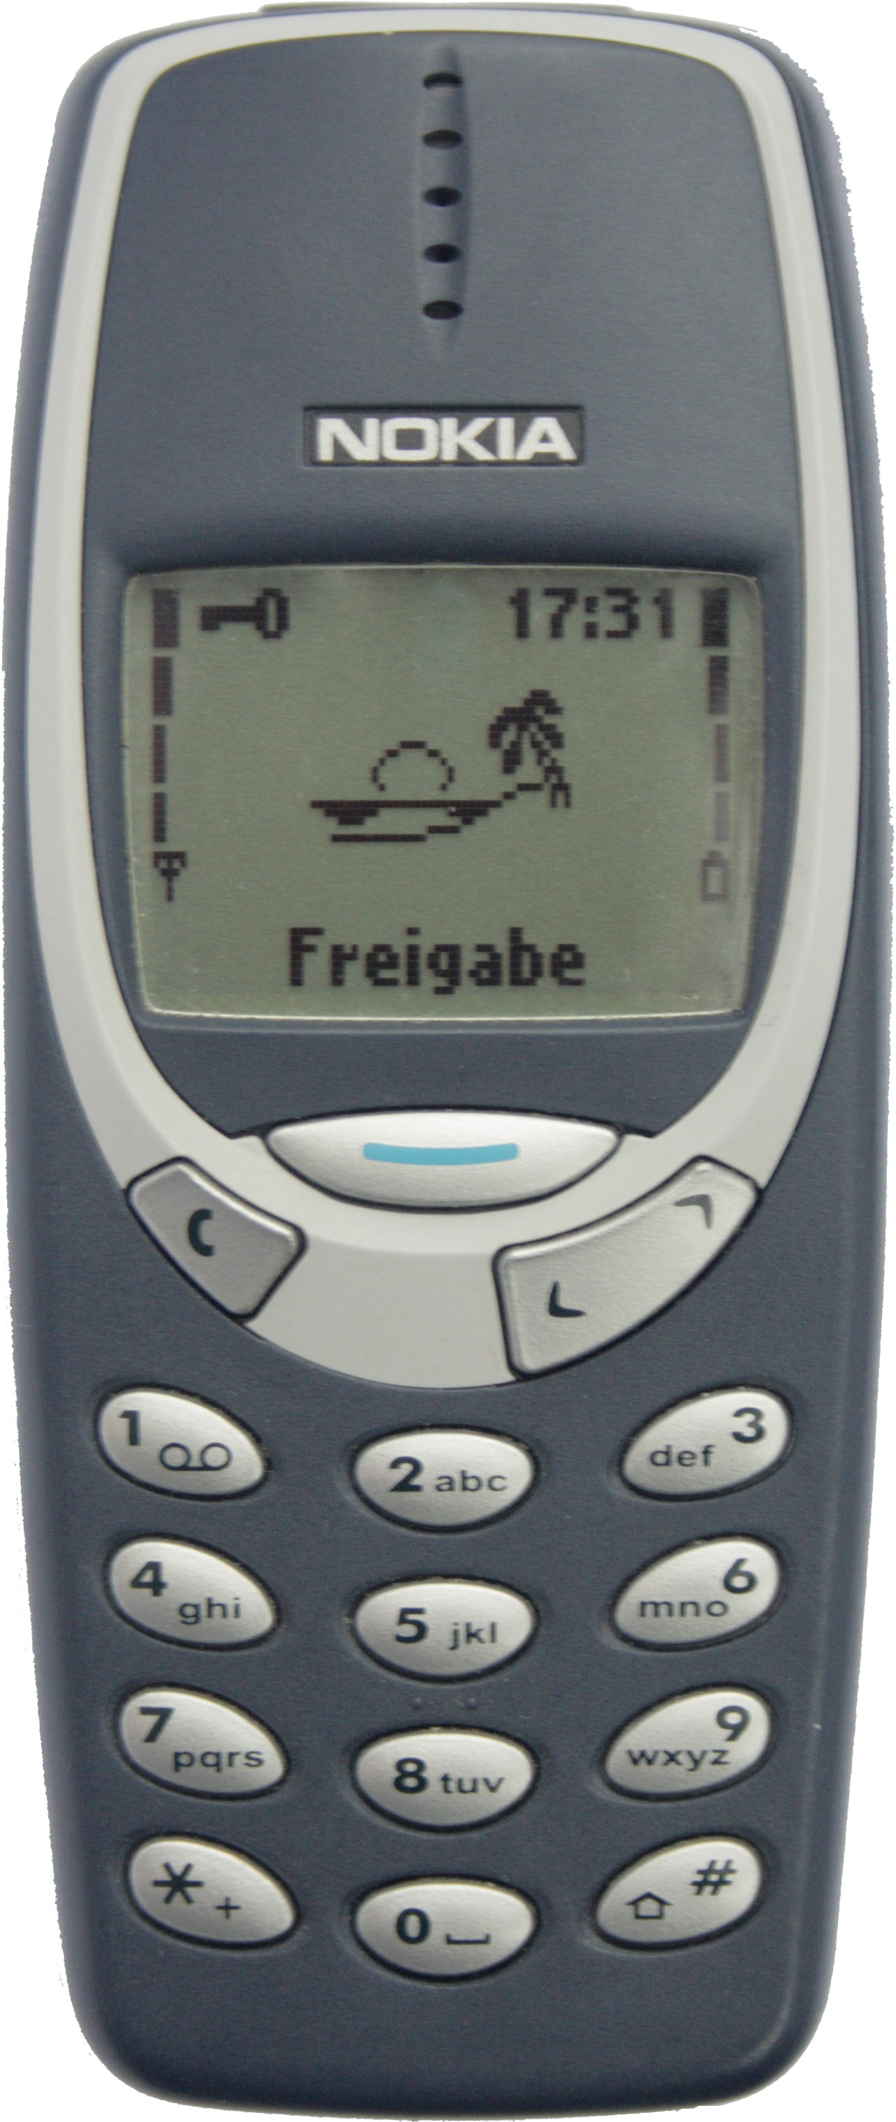

PROBLEM Z

Proper typing is becoming an essential part of culture. If you are still not using all ten fingers for typing, you have to re-learn typing – then you will type faster and feel more comfortable and enjoyable.

There are a lot of web sites teaching proper typing. The following image depicts the basic principle; the keys needed to press with the same finger are of the same color.

* The yellow keys need to be pressed with the pinky
* The blue ones with the ring finger
* The green ones with the middle finger
* The red ones with the index finger.
* Naturally, the left hand presses the left side of the keyboard (starting with keys 5, T, G, B to the left), the right hand presses the right side (starting with keys 6, Y, H, N to the right). Thumbs are responsible for space.



**Your task is to output how many times each finger, excluding thumbs, participated in typing the given string properly.**

INPUT

The first and only line of input contains of a string consisting of at least one and at most fifty characters. The string doesn’t contain whitespaces and consists only of characters depicted on the image above.

OUTPUT

The output must consist of eight lines, in each line one integer denoting the number of presses of each finger, excluding thumbs, observed from left to right.

SAMPLES

|  |  |  |
| --- | --- | --- |
| Input:  AON=BOO; | Input:  PRINT’NY’[NASLA] | Input:  VIDI,KO,JE,DOSA |
| Output:  1  0  0  1  1  0  3  2 | Output:  2  1  0  2  4  1  1  5 | Output:  1  1  3  1  1  6  2  0 |